SRI CHANDRASEKHARENDRA SARASWATHI VISWA MAHAVIDYALAYA

(UNIVERSITY ESTABLISHED under section 3 of UGC Act 1956)

ENATHUR, KANCHIPURAM – 631 561



OBJECT ORIENTED PROGRAMMING IN JAVA

LABORATORY RECORD

Name : S.HARINHI

Reg. No : 112534076

Class : I YEAR BCA

Subject : UCAF252T40 – Data Structures And Algorithms

SRI CHANDRASEKHARENDRA SARASWATHI

VISWA MAHAVIDYALAYA
(University Established under section 3 of UGC Act 1956)



BONAFIDE CERTIFICATE

This is to Certify that this is the bonafide record of work done by Mr. S. HARINHI with Reg. No 112534076 of I Year BCA in the Data Structures And Algorithms Lab during the year 2026.

Staff-in-charge Head of the Department

Submitted for the Practical Examination held on ________________________

Internal Examiner External Examiner.

INDEX

S.No. | Date | Title | Page No. | Signature
1 | 06 Feb 2026 | Program to Search an Element In the Array. | 01
2 | 13 Feb 2026 | Program to Search an Element In the Array using Binary Search. | 03
3 | 20 Feb 2026 | Program to Sort an Array using Bubble Sort.
4 | 27 Feb 2026 | Program to Sort an Array using Selection Sort.
5 | 06 Feb 2026 | Program to Sort an Array using Insertion Sort.
6 | 13 Mar 2026 | Program to Implement a Stack Using Arrays.
7 | 20 Mar 2026 | Program to Implement a Queue Using Arrays
8 | 27 Mar 2026 | Program to Implement a Stack using Linked List
9 | 03 Apr 2026 | Program to Implement a Queue using Linked List

1 | Program to Search an Element In the Array | 06 Feb 2026

AIM:
Program to Search an Element in the Array.

ALGORITHM:
Step 1: Start.
Step 2: Declare the counter variable (i), array size (n), element to search found.
Step 3: Read = n, I = 0
Step 4: Read arr[i]
Step 5: increment I (i++)
Step 6: if (i<n) goto step 4.
Step 7: Read element to search (search).
Step 8: I = 0
Step 9: if arr[i] ! = Search goto step 12.
Step 10: found = 1.
Step 11: print “Element found at index = I” go to step 15.
Step 12: i++
Step 13: if I < n go to step 9.
Step 14: if found not equal to 1, print “Element not found”.
Step 15: stop.

FLOW CHART:

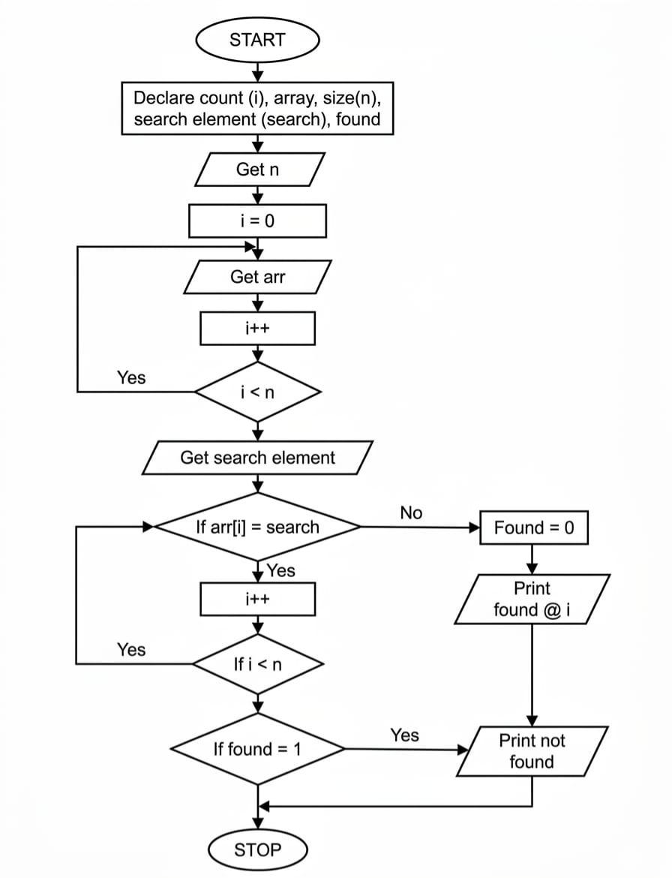

SOURCE CODE:
#include <stdio.h>
int main()
{
int n, i, search, found = 0;
// Input number of elements in the array
printf(“Enter number of elements in the array: “);
scanf(“%d”, &n);
int arr[n];
// Input array elements
printf(“Enter elements of the array: \n”);
for(i= 0; i< n; i++) {
scanf(“%d”, &arr[i]);
}
// Input the element to search
printf(“Enter element to search: “);
scanf(“%d”, &search);
// Linear search
for(i = 0; i< n; i++)
{
if(arr[i] == search)
{
found = 1;
printf(“Element %d found at index %d.\n”, search, i);
break;
}
}
// If element is not found
if(!found)
{
printf(“Element %d not found in the array.\n”, search);
}
return 0;
}

SAMPLEOUTPUT:
Enter number of elements in the array: 5
Enter elements of the array:
6
3
8
5
2
Enter element to search: 8
Element 8 found at index 2.
NEGATIVE I/O
Enter number of elements in the array: 5
Enter elements of the array:
6
3
8
5
2
Enter element to search: 10
Element 10 not found in the array

2 | Program to Search an Element In the Array using Binary Search | 13 Feb 2026

AIM:
Program to Search an Element in the Array using Binary Search.

ALGORITHM:
Step 1: start
Step 2: declare no of elements (n) elements to search (key)
Step 3: initialization array with n(arr[n])
Step 4: i=0
Step 5: get arr[i]
Step 6: i++
Step 7: if i<n goto step 5,else continue
Step 8: read element to search(key)
Step 9: result = binary search(arr,n,key)
Step 10: if (result!=1)
Step 11: print element found at position(result)else
Print element not found
Step 12: stop

ALGORITHM FOR BINARY SEARCH:
Step 1: int low=o, high=n-1
Step 2: if low(<=high)
Step 3: mid=(low+high)/2
Step 4: if (arr[mid]==key)
Return mid
Step 5: else if (arr[mid]<key)
Low=mid+1
Else
High+mid-1
Step 6: goto step 2
Step 7: return-1

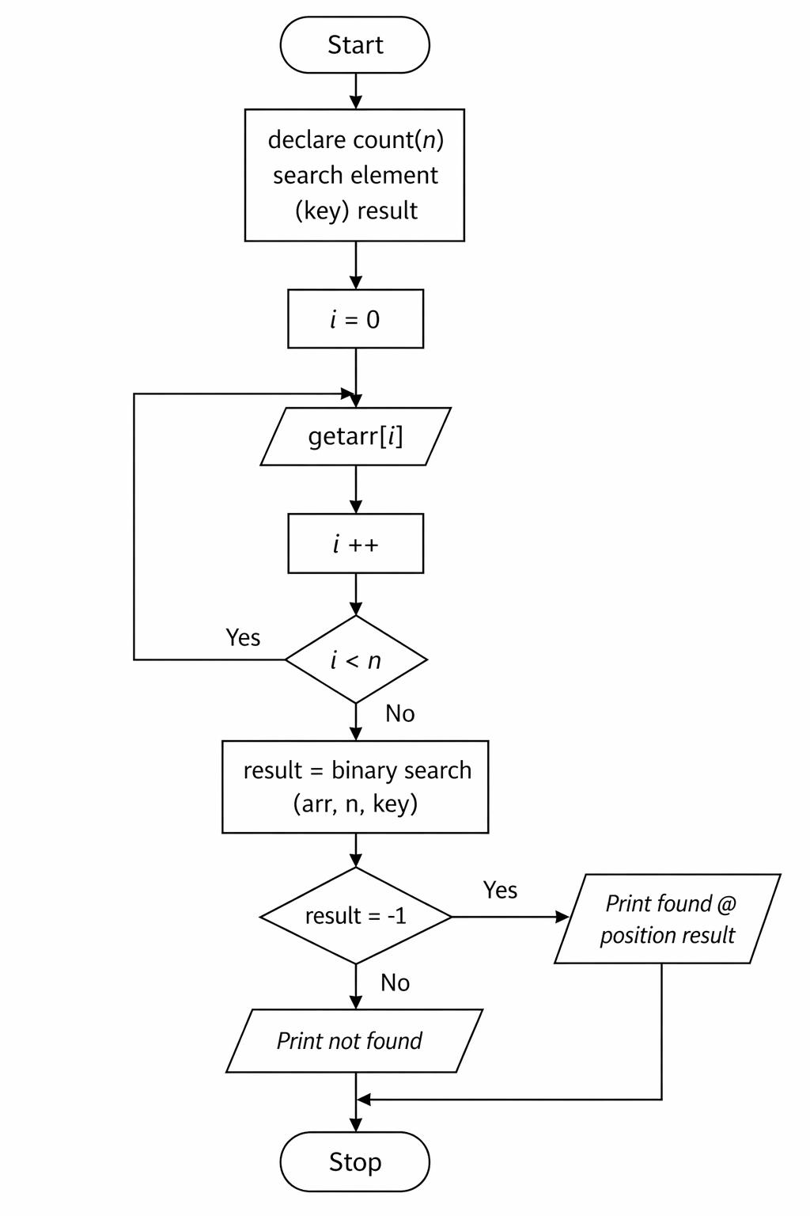
FLOW CHART:
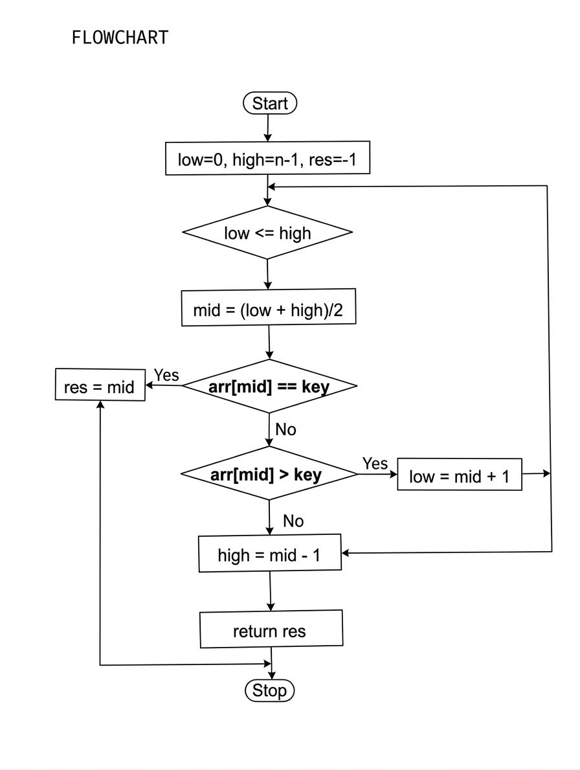

SOURCE CODE:
#include<stdio.h>
Int binarysearch(int arr[],int n, int key)
{
Int low=0,high=n-1,mid;
While(low<=high)
{
Mid=(low+high)/2;
If (arr[mid]==key)
Return mid;
//element found
Else if(arr[mid]<key)
Low=mid+1;
//search right half
Else
High=mid-1;
//search left half
}
Return 1;
//element not found
}
Int main()
{
Int n,key,result;
Printf(“enter number of element:”);
Scanf(“%d”,&n);
Int arr[n];
Printf(“enter %d sorted element:\n”,n);
Int I;
For(i=0;i<n;i++){
Scanf(“%d”,&arr[i]);
}
Printf(“enter element to search:”);
Scanf(“%d”,&key);
Result = binarysearch(arr, n, key);
If(result!=-1)
Printf(“element found at index %d \n”,result);
Else
Printf(“element not found \n”);
Return 0;
}

SAMPLE OUTPUT:
Enter number of elements: 5
Enter 5 sorted elements:
11
12
13
14
15
Enter element to search: 14
Element found at index 3

3 | Program to Sort an Array using Bubble Sort | 20 Feb 2026

AIM:
Program to Sort an Array using Bubble Sort.

ALGORITHM:
Step 1: Start the program
Step 2: Read the number of elemnt n
Step 3: Declare an array arr[n]
Step 4: Input n elements into the array
Step 5: for i=0 to n-2
Step 6: for j=0 to n-i-2
Step 7: if arr[j]>arr[j+1]
Swap arr[j] and arr[j+1]
Temp=arr[j]
Arr[j]=arr[j+1]
Arr[j+1]=temp
Step 8: Print the sorted array
Step 9: Stop

FLOW CHART:

SOURCE CODE :
#include<Stdio.h>
Int main()
{
Int n,temp;
Int I,j;
Printf(“enter number of element:”);
Scanf(“%d”,&n);
Int arr[n];
Printf(“enter %d elements:\n”,n);
For(i=0;i<n;i++)
Scanf(“%d”,&arr[i]);
//bubble sort logic
For(i=0;i<n;i++)
{
For(j=0;j<n;j++)
{
If(arr[j]>arr[j+1])
{
Temp=arr[j];
Arr[j]=arr[j+1];
Arr[j+1]=temp;
}
}
}
Printf(“sorted array:\n”);
For(i=0;i<n;i++)
Printf(“%d”,arr[i]);
Return 0;
}

SAMPLE OUTPUT:
Enter number of element:5
Enter 5 element:
25
32
95
65
23
Sorted array
23 25 32 65 95

4 | Program to Sort an Array using Selection Sort | 27 Feb 2026

AIM:
Program to Sort an Array using Selection Sort.

ALGORITHM:
Step 1: start
Step 2: declare element count (n),
Step 3: get n
Step 4: declare arr [n]
Step 5: get arr [i]
Step 6: i++
Step 7: repeat from step 5 till i<n
Step 8: I = 0
Step 9 : minindex = i
Step 10: j = i+1
Step 11: if arr [i]<arr
Step 12: temp = arr [i]
Arr[i] = arr[minindex]
Arr[minindex] = temp
Step 13: j++
Step 14: repeat from step 11 till j<n
Step 15: i++
Step 16: repeat from step 9 till i<n-1
Step 17: stop I = 0
Step 18: print arr [i]
Step 19: i++
Step 20: repeat from step 18 till i<n
Step 21: stop

FLOW CHART:

SOURCE CODE:
#include <stdio.h>
Int main()
{
Int n, temp, minIndex;
Printf(“Enter number of elements: “);
Scanf(“%d”, &n);
Int arr[n];
Printf(“Enter %d elements:\n”, n);
For (int I = 0; I < n; i++)
Scanf(“%d”, &arr[i]);
// Selection Sort logic
For (int I = 0; I < n – 1; i++)
{
minIndex = I;
for (int j = I + 1; j < n; j++)
{
If (arr[j] < arr[minIndex])
minIndex = j;
}
// Swap
Temp = arr[i];
Arr[i] = arr[minIndex];
Arr[minIndex] = temp;
}
Printf(“Sorted array:\n”);
For (int I = 0; I < n; i++)
Printf(“%d “, arr[i]);
Return 0;
}

OUTPUT:
Enter number of elements: 6
Enter 6 elements:
12
14
11
22
20
19
Sorted array:
11 12 14 19 20 22

5 | Program to Sort an Array using Insertion Sort. | 06 Feb 2026

AIM:
Program to Sort an Array using Insertion Sort.

ALGORITHM:
Step 1: Start
Step 2: Read the number of elements
○ Input n from the user
Step 3: Declare an array of size n
○ arr[n]
Step 4: Read array elements iteratively
○ For I = 0 to n-1 do:
■ Prompt user: “Enter element i+1”
■ Read arr[i] from user input
Step 5: Sort the array using Insertion Sort
○ For I = 1 to n-1 do:
■ Set key = arr[i]
■ Set j = I – 1
■ Compare and shift elements:
■ While j >= 0 and arr[j] > key do:
■ Move arr[j] one position right: arr[j + 1] = arr[j]
■ Decrement j = j – 1
■ Insert the key at its correct position:
■ arr[j + 1] = key
■ Repeat for the next element (I = I + 1)
Step 6: Display the sorted array
○ For I = 0 to n-1 do:
■ Print arr[i]
Step 7: End

FLOW CHART:

SOURCE CODE:
#include <stdio.h>
Int main()
{
Int n, key, j;
Printf(“Enter number of elements: “);
Scanf(“%d”, &n);
Int arr[n];
Printf(“Enter %d elements:\n”, n);
For (int I = 0; I < n; i++)
Scanf(“%d”, &arr[i]);
// Insertion Sort logic
For (int I = 1; I < n; i++)
{
Key = arr[i];
J = I – 1;
While (j >= 0 && arr[j] > key)
{
Arr[j + 1] = arr[j];
j--;
}
Arr[j + 1] = key;
}
Printf(“Sorted array:\n”);
For (int I = 0; I < n; i++)
Printf(“%d “, arr[i]);
Return 0;
}

SAMPLE OUTPUT:
Enter number of elements: 6
Enter 6 elements:
12
14
11
22
20
19
Sorted array:
11 12 14 19 20 22

6 | Program to Implement a Stack Using Arrays | 13 March 2026

AIM:
Program to Implement a Stack Using Arrays.

ALGORITHM:
Step 1: Start – Begin program execution.
Step 2: Initialize Stack – Define a stack of size MAX (5).
Step 3: Initialize top – Set top = -1 to indicate the stack is empty.
Step 4: Display Main Menu – Show options: 1. Push 2. Pop 3. Display 4. Exit.
Step 5: Read User Choice – Read the choice from the user.
● If choice = 1, go to Push Operation Steps.
● If choice = 2, go to Pop Operation Steps.
● If choice = 3, go to Display Operation Steps.
● If choice = 4, go to Exit Operation Steps.
● Otherwise, print “Invalid choice” and return to Step 4 (Display Main Menu).

Push ( ) Operation Steps (Choice = 1)
Step P1: Check Stack Overflow – If top == MAX – 1, print “Stack Overflow” and return to step 4 (Display MainMenu).
Step P2: Read Item – Read the element to push from the user.
Step P3: Increment top – top = top + 1.
Step P4: Assign Stack Element – stack[top] = item.
Step P5: Print Success Message – Print “Element pushed successfully” and return to Step 4 (Display Main Menu).

Pop( ) Operation Steps (Choice = 2)
Step O1: Check Stack Underflow – If top == -1, print “Stack Underflow” and return toStep4 (Display Main Menu).
Step O2: Print Popped Element – Print stack[top].
Step O3: Decrement top – top = top – 1 and return to Step 4 (Display Main Menu).

Display( ) Operation Steps (Choice = 3)
Step D1: Check if Stack is Empty – If top == -1, print “Stack is empty” and return to Step 4 (Display Main Menu).
Step D2: Loop Through Stack – For I = top down to 0, print stack[i].
Step D3: Return to Main Menu – Go back to Step 4 (Display Main Menu).

Exit( ) Operation Steps (Choice = 4)
Step E1: Print Exit Message – Print “Exiting program”.
Step E2: End – Program execution ends.

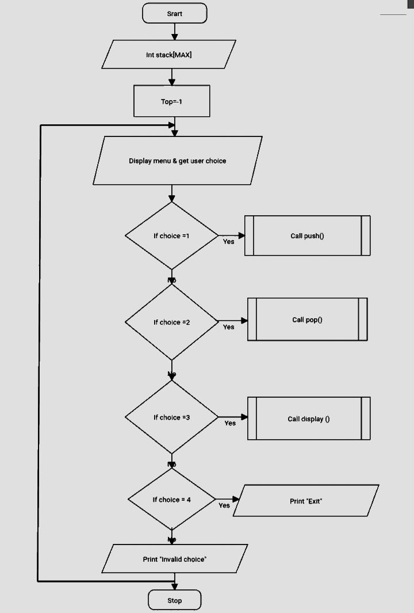
FLOWCHART:
- PUSH( )

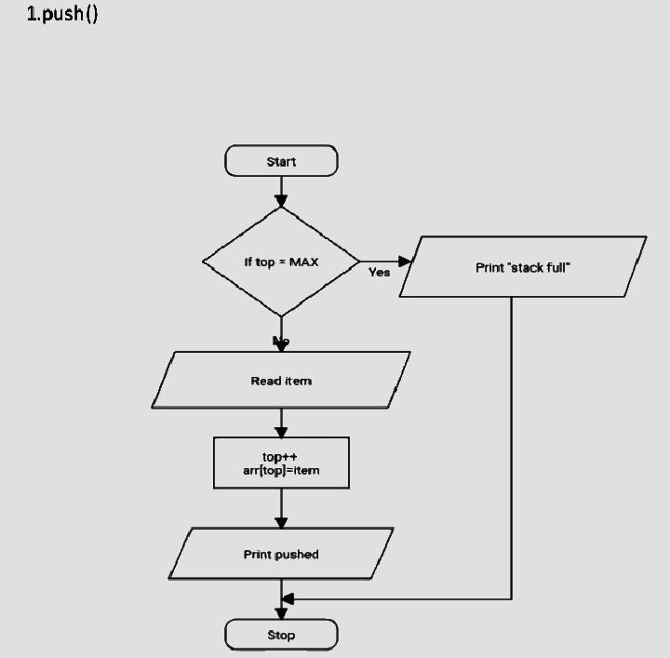

  - POP( )
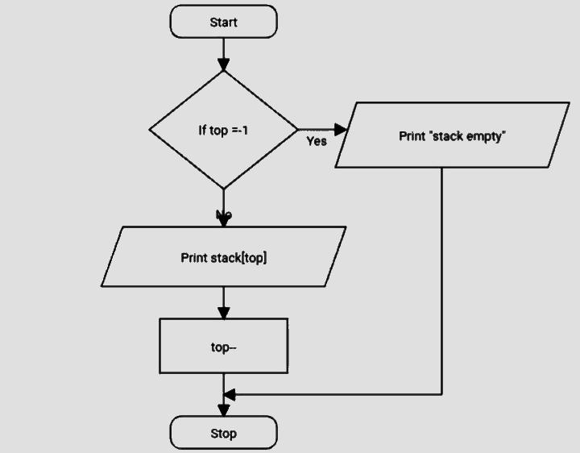

  - DISPLAY( )
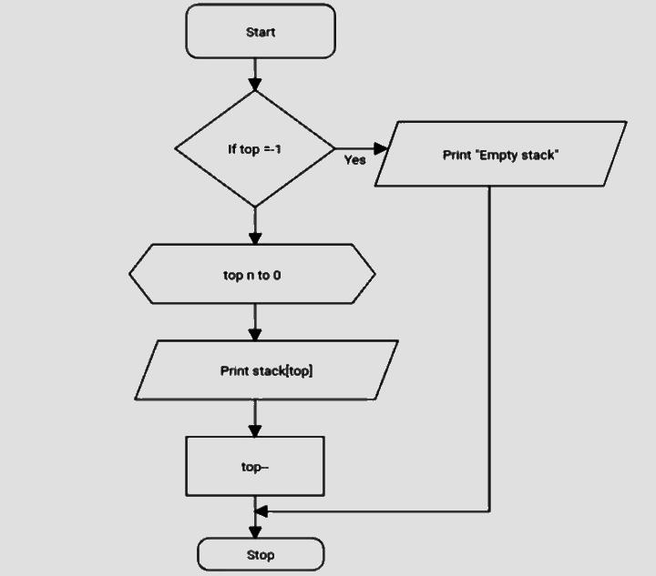

SOURCE CODE:
#include <stdio.h>
#define MAX
Int stack[MAX];
Int top = -1;
// Push operation
Void push()
{
Int item;
If (top == MAX – 1)
{
Printf(“Stack Overflow!\n”);
Return;
}
Printf(“Enter element to push: “);
Scanf(“%d”, &item);
Stack[++top] = item;
Printf(“Element pushed successfully.\n”);
}
// Pop operation
Void pop()
{
If (top == -1)
{
Printf(“Stack Underflow!\n”);
Return;
}
Printf(“Popped element: %d\n”, stack[top--]);
}
// Display stack elements
Void display()
{
If (top == -1)
{
Printf(“Stack is empty.\n”);
Return;
}
Printf(“Stack elements:\n”);
For (int I = top; I >= 0; i--)
Printf(“%d\n”, stack[i]);
}
Int main()
{
Int choice;
Do
{
Print(“\n--- Stack Menu ---\n”);
Printf(“1. Push\n2. Pop\n3. Display\n4. Exit\n”);
Printf(“Enter your choice: “);
Scanf(“%d”, &choice);
Switch (choice)
{
Case 1:
Push();
Break;
Case 2:
Pop();
Break;
Case 3:
Display();
Break;
Case 4:
Printf(“Exiting program.\n”);
Break;
Default:
Printf(“Invalid choice!\n”);
}
} while (choice != 4);

Return 0;
}

SAMPLE OUTPUT:
--- Stack Menu ---
1. Push
2. Pop
3. Display
4. Exit
Enter your choice: 1
Enter element to push: 12
Element pushed successfully.

--- Stack Menu ---
1. Push
2. Pop
3. Display
4. Exit
Enter your choice: 1
Enter element to push: 13
Element pushed successfully.

--- Stack Menu ---
1. Push
2. Pop
3. Display
4. Exit
Enter your choice: 3
Stack elements:
13
12

--- Stack Menu ---
1. Push
2. Pop
3. Display
4. Exit
Enter your choice: 2
Popped element: 13

--- Stack Menu ---
1. Push
2. Pop
3. Display
4. Exit
Enter your choice: 3
Stack elements:
12

--- Stack Menu ---
1. Push
2. Pop
3. Display
4. Exit
Enter your choice:
4
Exiting program.

7 | Program to Implement a Queue Using Arrays | 20 March 2026

AIM:
Program to Implement a Queue Using Arrays

ALGORITHM:
Step 1: Start – Begin program execution.
Step 2: Initialize Queue – Define a queue of size MAX (5).
Step 3: Initialize front and rear – Set front = -1 and rear = -1 to indicate the queue is empty.
Step 4: Display Main Menu – Show options: 1. Enqueue 2. Dequeue 3. Display 4. Exit.
Step 5: Read User Choice – Read the choice from the user.
● If choice = 1, go to Enqueue Operation Steps.
● If choice = 2, go to Dequeue Operation Steps.
● If choice = 3, go to Display Operation Steps.
● If choice = 4, go to Exit Operation Steps.
● Otherwise, print “Invalid choice” and return to Step 4 (Display Main Menu).

Enqueue( ) Operation Steps (Choice = 1)
Step E1: Check Queue Overflow – If rear == MAX – 1, print “Queue Overflow” and return to Step 4 (Display Main Menu).
Step E2: Read Item to Insert – Read the element to enqueue from the user.
Step E3: Check if Queue Empty – If front == -1, set front = 0.
Step E4: Increment rear – rear = rear + 1.
Step E5: Assign Queue Element – queue[rear] = item.
Step E6: Print Success Message – Print “Element inserted successfully” and return to Step 4 (Display Main Menu).

Dequeue( ) Operation Steps (Choice = 2)
Step D1: Check Queue Underflow – If front == -1 or front > rear, print “Queue Underflow” and return to Step 4(Display Main Menu).
Step D2: Print Deleted Element – Print queue[front].
Step D3: Increment front – front = front + 1 and return to Step 4 (Display Main Menu).

Display( ) Operation Steps (Choice = 3)
Step DS1: Check if Queue is Empty – If front == -1 or front > rear, print “Queue is empty” and return to Step 4(Display Main Menu).
Step DS2: Loop Through Queue – For I = front to rear, print queue[i].
Step DS3: Return to Main Menu – Go back to Step 4 (Display Main Menu).

Exit Operation Steps (Choice = 4)
Step X1: Print Exit Message – Print “Exiting program”.
Step X2: End – Program execution ends.

FLOWCHART:

SOURCE CODE:
#include <stdio.h>
#define MAX 5
Int queue[MAX];
Int front = -1, rear = -1;
// Insert element (Enqueue)
Void enqueue()
{
Int item;
If (rear == MAX – 1)
{
Printf(“Queue Overflow!\n”);
Return;
}
Printf(“Enter element to insert: “);
Scanf(“%d”, &item);
If (front == -1)
Front = 0;
Queue[++rear] = item;
Printf(“Element inserted successfully.\n”);
}
// Delete element (Dequeue)
Void dequeue()
{
If (front == -1 || front > rear)
{
Printf(“Queue Underflow!\n”);
Return;
}
Printf(“Deleted element: %d\n”, queue[front++]);
}
// Display queue elements
Void display()
{
If (front == -1 || front > rear)
{
Printf(“Queue is empty.\n”);
Return;
}
Printf(“Queue elements:\n”);
For (int I = front; I <= rear; i++)
Printf(“%d “, queue[i]);
Printf(“\n”);
}
Int main()
{
Int choice;
Do
{
Printf(“\n--- Queue Menu ---\n”);
Printf(“1. Enqueue\n2. Dequeue\n3. Display\n4. Exit\n”);
Printf(“Enter your choice: “);
Scanf(“%d”, &choice);
Switch (choice)
{
Case 1:
Enqueue();
Break;
Case 2:
Dequeue();
Break;
Case 3:
Display();
Break;
Case 4:
Printf(“Exiting program.\n”);
Break;
Default:
Printf(“Invalid choice!\n”);
}
} while (choice != 4);
Return 0;
}

SAMPLE OUTPUT:
--- Queue Menu ---
1. Enqueue
2. Dequeue
3. Display
4. Exit
Enter your choice: 1
Enter element to insert: 16
Element inserted successfully.

--- Queue Menu ---
1. Enqueue
2. Dequeue
3. Display
4. Exit
Enter your choice: 1
Enter element to insert: 23
Element inserted successfully.

--- Queue Menu ---
1. Enqueue
2. Dequeue
3. Display
4. Exit
Enter your choice: 1
Enter element to insert: 36
Element inserted successfully.

--- Queue Menu ---
1. Enqueue
2. Dequeue
3. Display
4. Exit
Enter your choice: 3
Queue elements:
16 23 36

--- Queue Menu ---
1. Enqueue
2. Dequeue
3. Display
4. Exit
Enter your choice: 3
Queue elements:
16 23 36

--- Queue Menu ---
1. Enqueue
2. Dequeue
3. Display
4. Exit
Enter your choice: 2
Deleted element: 16

--- Queue Menu ---
1. Enqueue
2. Dequeue
3. Display
4. Exit
Enter your choice: 3
Queue elements:
23 36

--- Queue Menu ---
1. Enqueue
2. Dequeue
3. Display
4. Exit
Enter your choice: 4
Exiting program.

8 | Program to Implement a Stack using Linked List | 27 Apr 2026

AIM:
Program to Implement a Stack using Linked List

ALGORITHM:
FLOWCHART:
SOURCE CODE:
#include <stdio.h>
#include <stdlib.h>
// Structure for stack node
Struct node
{
Int data;
Struct node *next;
};
Struct node *top = NULL;
// Push operation
Void push()
{
Int item;
Struct node *newNode;
newNode = (struct node *)malloc(sizeof(struct node));
if (newNode == NULL)
{
Printf(“Heap Overflow!\n”);
Return;
}
Prints(“Enter element to push: “);
Scanf(“%d”, &item);
newNode->data = item;
newNode->next = top;
top = newNode;
printf(“Element pushed successfully.\n”);
}
// Pop operation
Void pop()
{
Struct node *temp;
If (top == NULL)
{
Printf(“Stack Underflow!\n”);
Return;
}
Temp = top;
Printf(“Popped element: %d\n”, temp->data);
Top = temp->next;
Free(temp);
}
// Display stack
Void display()
{
Struct node *temp;
If (top == NULL)
{
Printf(“Stack is empty.\n”);
Return;
}
Printf(“Stack elements:\n”);
Temp = top;
While (temp != NULL)
{
Printf(“%d\n”, temp->data);
Temp = temp->next;
}
}
Int main()
{
Int choice;
Do
{
Printf(“\n--- Stack Menu ---\n”);
Printf(“1. Push\n2. Pop\n3. Display\n4. Exit\n”);
Printf(“Enter your choice: “);
Scanf(“%d”, &choice);
Switch (choice)
{
Case 1:
Push();
Break;
Case 2:
Pop();
Break;
Case 3:
Display();
Break;
Case 4:
Printf(“Exiting program.\n”);
Break;
Default:
Printf(“Invalid choice!\n”);
}
} while (choice != 4);
Return 0;
}

SAMPLE OUTPUT:
--- Stack Menu ---
1. Push
2. Pop
3. Display
4. Exit
Enter your choice: 1
Enter element to push: 23
Element pushed successfully.

--- Stack Menu ---
1. Push
2. Pop
3. Display
4. Exit
Enter your choice: 1
Enter element to push: 35
Element pushed successfully.

--- Stack Menu ---
1. Push
2. Pop
3. Display
4. Exit
Enter your choice: 1
Enter element to push: 36
Element pushed successfully.

--- Stack Menu ---
1. Push
2. Pop
3. Display
4. Exit
Enter your choice: 3
Stack elements:
36
35
23

--- Stack Menu ---
1. Push
2. Pop
3. Display
4. Exit
Enter your choice: 3
Stack elements:
36
35
23

--- Stack Menu ---
1. Push
2. Pop
3. Display
4. Exit
Enter your choice:
2
Popped element: 36

--- Stack Menu ---
1. Push
2. Pop
3. Display
4. Exit
Enter your choice: 3
Stack elements:
35
23

--- Stack Menu ---
1. Push
2. Pop
3. Display
4. Exit
Enter your choice: 4
Exiting program.

9 | Program to Implement a Queue using Linked List | 03 Apr 2026

AIM:
Program to Implement a Queue using Linked List

ALGORITHM:

FLOWCHART:

SOURCE CODE;
#include <stdio.h>
#include <stdlib.h>
// Structure for queue node
Struct node
{
Int data;
Struct node *next;
};
Struct node *front = NULL;
Struct node *rear = NULL;
// Enqueue operation
Void enqueue()
{
Int item;
Struct node *newNode;
newNode = (struct node *)malloc(sizeof(struct node));
if (newNode == NULL)
{
Printf(“Heap Overflow!\n”);
Return;
}
Printf(“Enter element to insert: “);
Scanf(“%d”, &item);
newNode->data = item;
newNode->next = NULL;
if (rear == NULL)
{
Front = rear = newNode;
}
Else
{
Rear->next = newNode;
Rear = newNode;
}
Printf(“Element inserted successfully.\n”);
}
// Dequeue operation
Void dequeue()
{
Struct node *temp;
If (front == NULL)
{
Printf(“Queue Underflow!\n”);
Return;
}
Temp = front;
Printf(“Deleted element: %d\n”, temp->data);
Front = front->next;
If (front == NULL)
Rear = NULL;
Free(temp);
}
// Display queue elements
Void display()
{
Struct node *temp;
If (front == NULL)
{
Printf(“Queue is empty.\n”);
Return;
}
Printf(“Queue elements:\n”);
Temp = front;
While (temp != NULL)
{
Printf(“%d “, temp->data);
Temp = temp->next;
}
Printf(“\n”);
}
Int main()
{
Int choice;
Do
{
Printf(“\n--- Queue Menu ---\n”);
Printf(“1. Enqueue\n2. Dequeue\n3. Display\n4. Exit\n”);
Printf(“Enter your choice: “);
Scanf(“%d”, &choice);
Switch (choice)
{
Case 1:
Enqueue();
Break;
Case 2:
Dequeue();
Break;
Case 3:
Display();
Break;
Case 4:
Printf(“Exiting program.\n”);
Break;
Default:
Printf(“Invalid choice!\n”);
}
} while (choice != 4);

Return 0;
}

SAMPLE OUTPUT;
--- Queue Menu ---
1. Enqueue
2. Dequeue
3. Display
4. Exit
Enter your choice: 1
Enter element to insert: 12
Element inserted successfully.

--- Queue Menu ---
1. Enqueue
2. Dequeue
3. Display
4. Exit
Enter your choice: 1
Enter element to insert: 51
Element inserted successfully.

--- Queue Menu ---
1. Enqueue
2. Dequeue
3. Display
4. Exit
Enter your choice: 3
Queue elements:
12 51

--- Queue Menu ---
1. Enqueue
2. Dequeue
3. Display
4. Exit
Enter your choice: 2
Deleted element: 12

--- Queue Menu ---
1. Enqueue
2. Dequeue
3. Display
4. Exit
Enter your choice: 3
Queue elements:
51

--- Queue Menu ---
1. Enqueue
2. Dequeue
3. Display
4. Exit
Enter your choice: 4
Exiting program.

